# Getting Started

## Getting acquainted with the Printer

1. Learning all the parts
2. Below is a picture of the printer with the parts labeled.
   1. Resin Cartridge: this is considered a consumable. It contains the resin and this thrown out when it is empty. Each resin cartridge contains 1 L of resin.
   2. Build Platform: This is the part to which the parts adhere when printing. It is replaced but only rarely.
   3. Resin Tank: This is considered a consumable. It holds the resin and is positioned above the laser. The printer informs you when the resin tank needs to be changed.

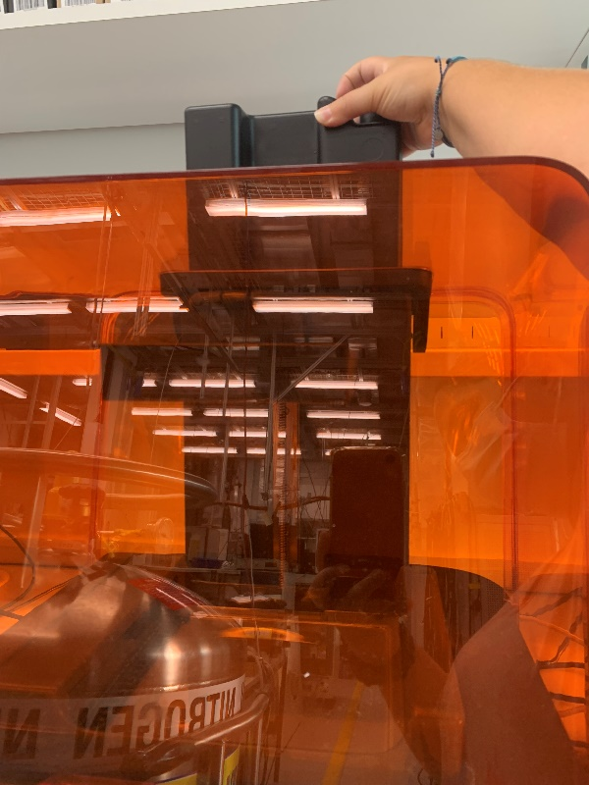

Resin Cartridge

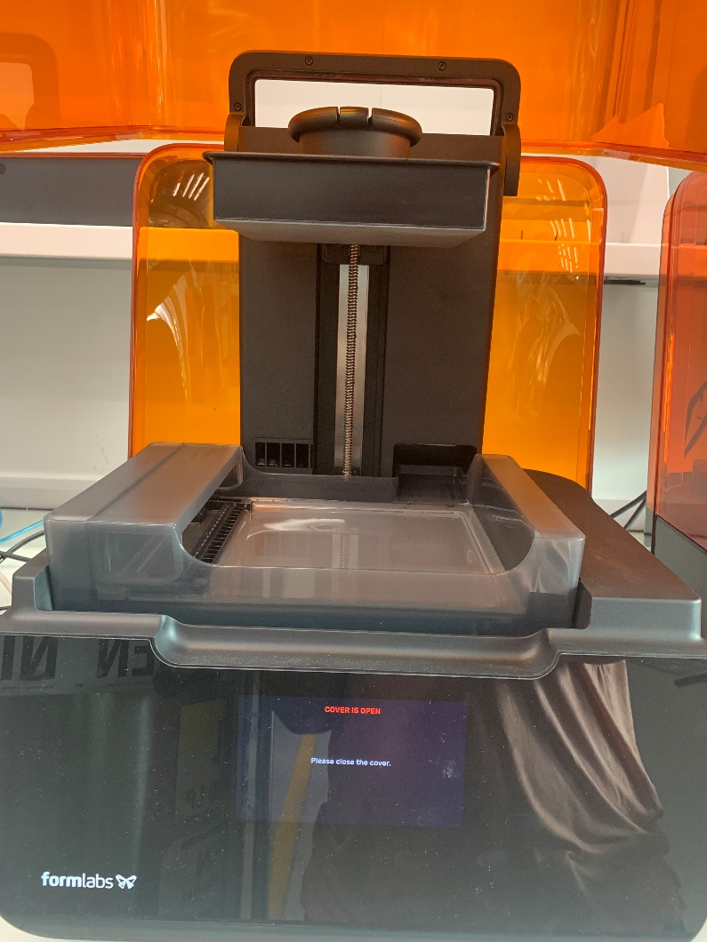

Build Platform

Resin Tank

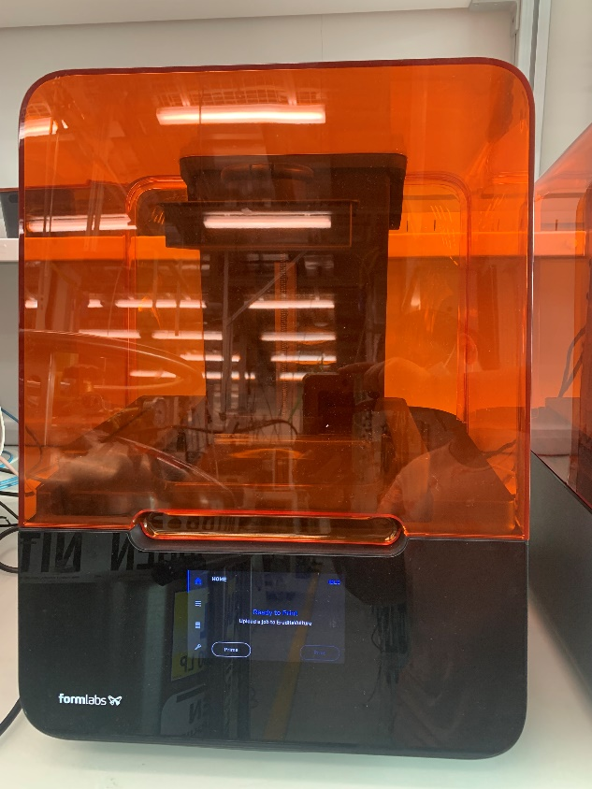

Build Platform

Resin Tank

Resin Cartridge

## Installing and using PreForm

1. In order to use the 3D printers you first need to download PreForm
   1. <https://formlabs.com/software/>
   2. Use this link and follow the download instructions
2. Once you have the software downloaded it is important to familiarize yourself with the main workflow
   1. When you first open the program, you will see a screen that looks like the first picture below.
   2. The box in the top right-hand corner (circled in red) is where you start. This allows you to select the desired 3D printer.

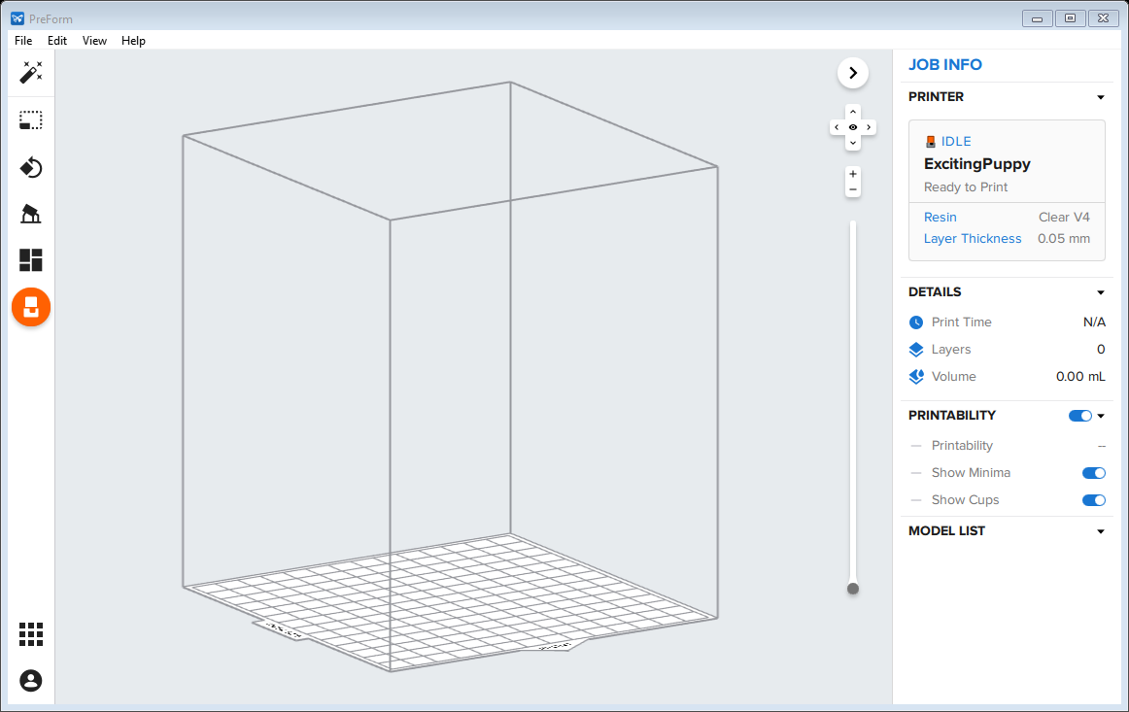

* 1. Click on this button and it will bring up the popup in the picture below.
     1. This will give you the ability to change resin type (using the dropdown menu circled in green) or layer thickness (using the slide bar circled in red). Usually the printer detect these things itself. However, sometimes the material selection below doesn’t match what the printer says (top dropdown circled in purple).
     2. The dop dropdown also tells you the status of the printer you have selected. It gives you the status of the resin cartridge and tank. It also lets you know if the printer is free or in use.
     3. Also notice the blue bar in the right of the top dropdown menu. This indicates how much resin is left in the current cartridge.
     4. Note: do not mess with the layer thickness initially. It is only necessary under particular circumstances.
  2. Each printer has a unique name. The one in the picture below is ExcitingPuppy as can be seen in the top dropdown (circled in purple).
  3. If the printer you see isn’t the one you want to print with, click the dropdown menu.
  4. When you do this you will get the screen below.

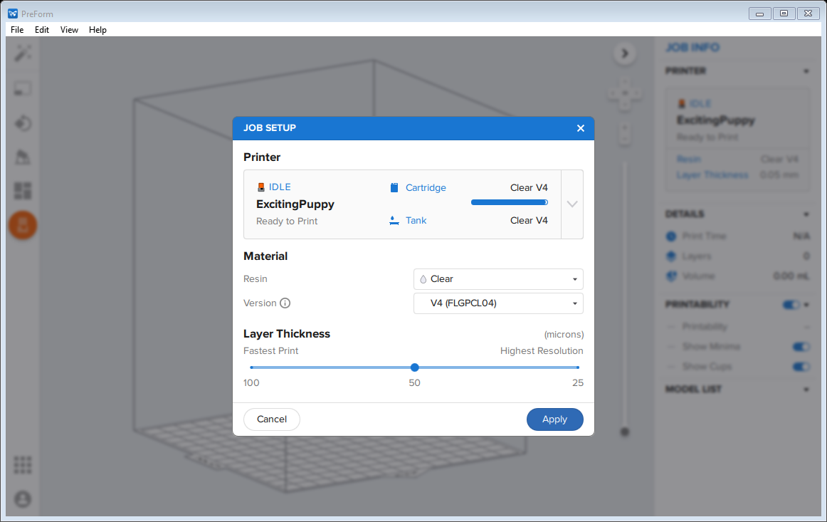

* 1. 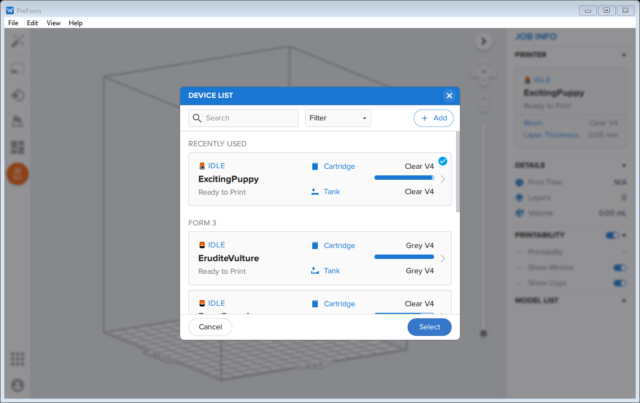You can scroll through the options until you find the printer you are interested in. You also have the option to search using the search bar at the top.
  2. If this is your first time printing you will need to click the add button in the top right corner (green circle in the picture below) and input the IP address in the appropriate format. Below is a list of the IP addresses for our printers along with the expected format.
     1. Exciting Puppy: 172.31.24.133
     2. Staunch Camel: 172.31.24.131
     3. Erudite Vulture: 172.31.24.132
     4. Exact Porpise: 172.31.24.134
  3. If a printer is missing consumables such as the resin tank or cartridge they will be listed as missing as is circled in red in the picture below.

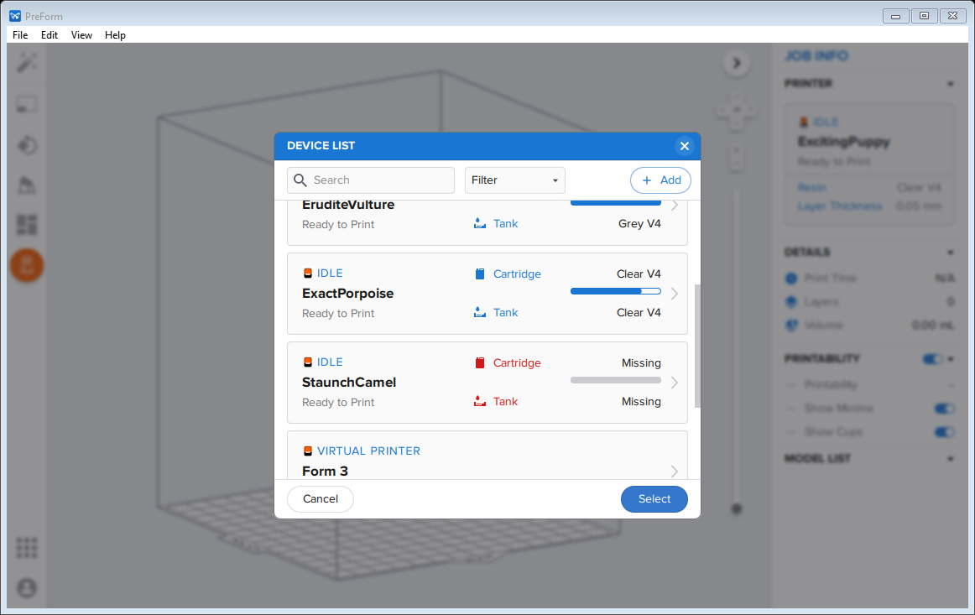

* 1. Once you have selected the desired printer the screen below will appear.
  2. Use this as an opportunity to verify that the printer is set up for the resin you are planning to print in. Then hit the select button.

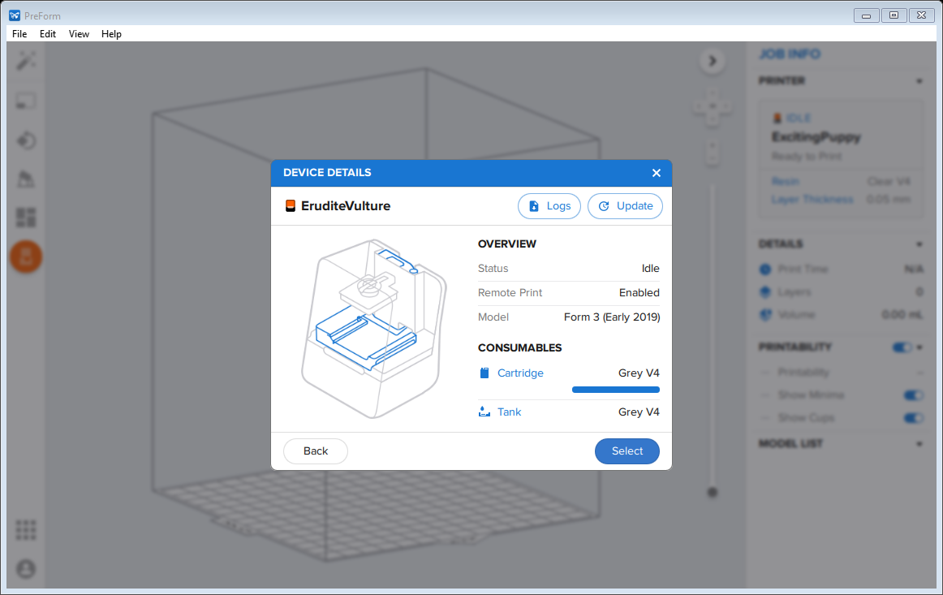

* 1. This will bring you back to the menu below.
  2. Watch out! Notice that the resin listed in “Material” isn’t what is actually in the printer. Change this before hitting the “Apply” button.
  3. 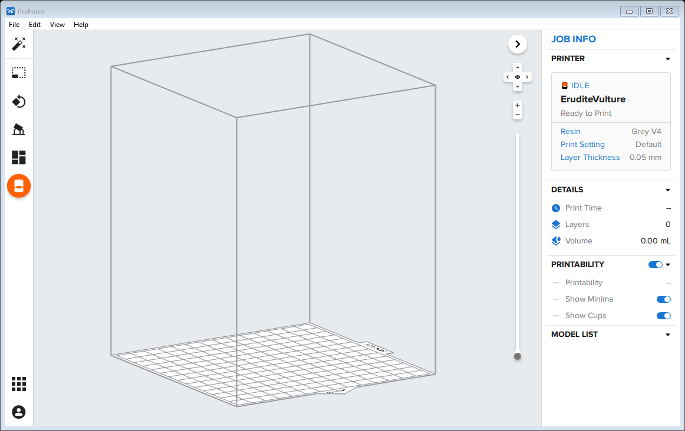Once you have hit “Apply” you will come back to this screen and are ready to start placing your parts.

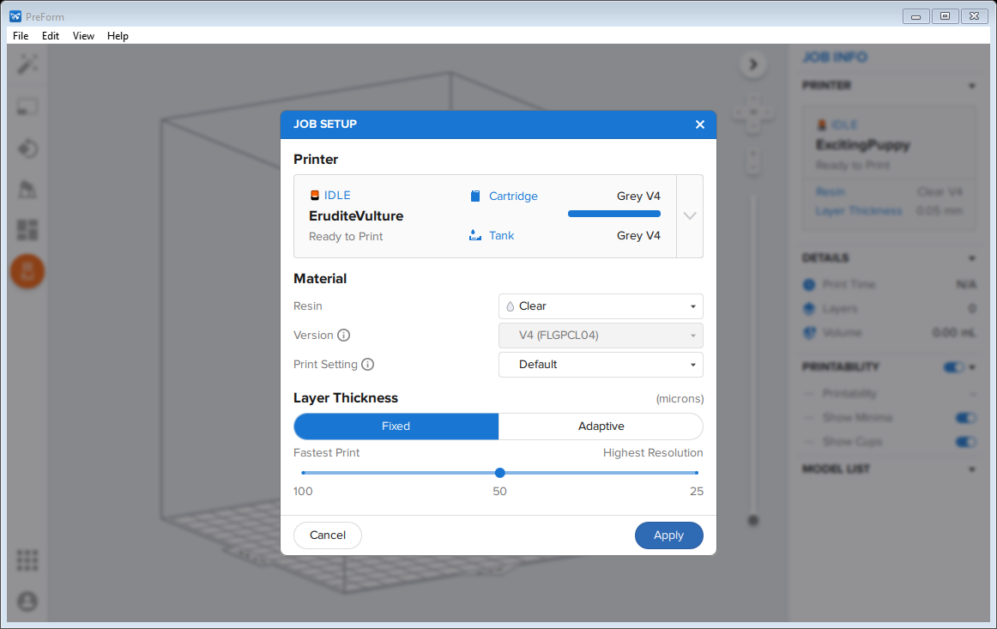

1. Before adding your parts you should ensure that you have exported them as .stl files.
   1. Go into inventor and click on file, export, CAD format and set the file type as .stl.
   2. The biggest thing is to check the settings when you export. Click options and make sure the units are set to millimeter and the resolution to high. If you don’t do this your parts may not export with the desired dimensions.

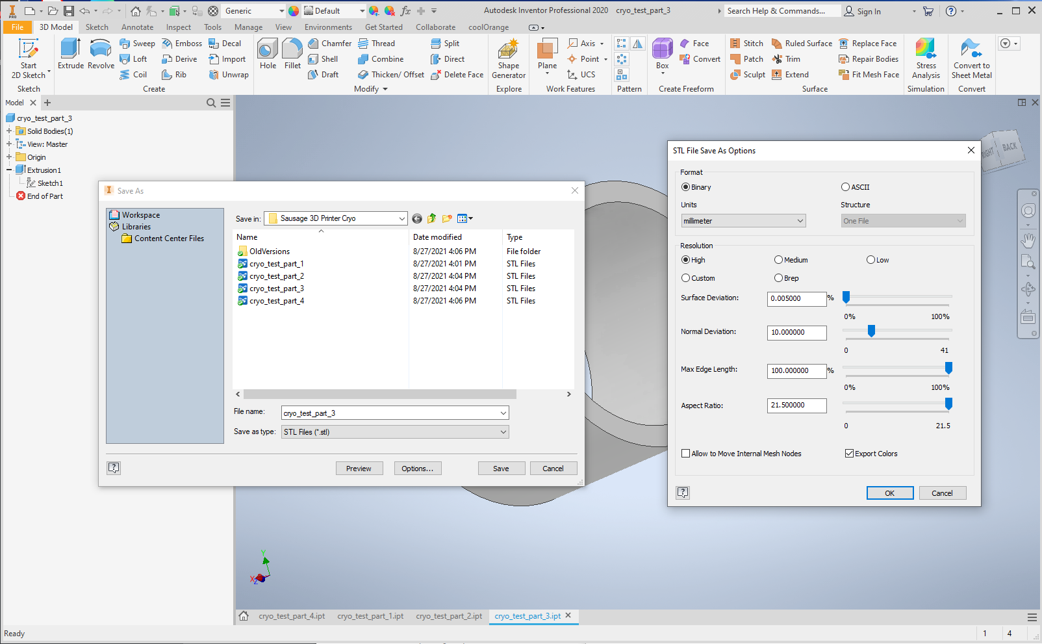

1. Now you can add your parts and prepare your print.
   1. To add a .stl file, click file then open. Select the part you want and press ok.

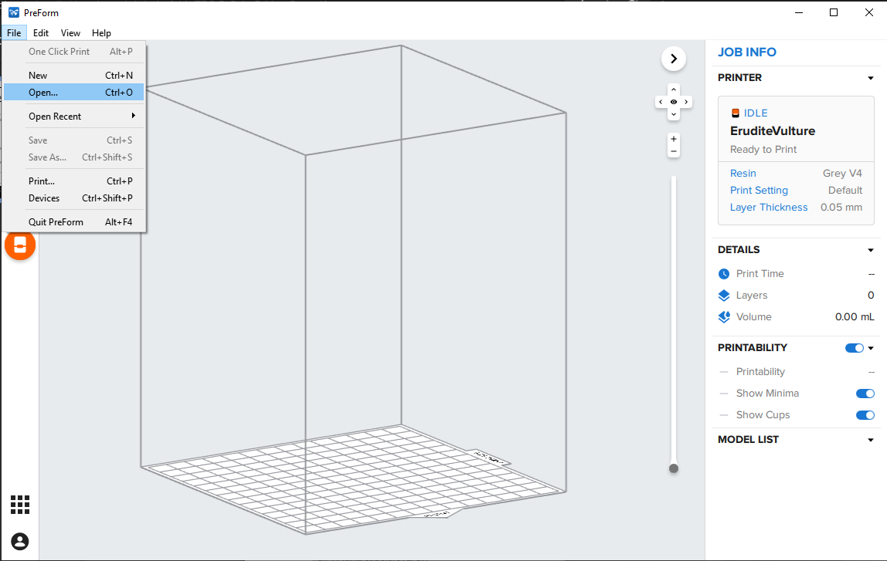

* 1. Once the part is in PreForm you can orient the part and place supports. Using the buttons on the left. Be sure the part is blue which means you have clicked on it to select it before using the menu on the left.
  2. The top button can be used to scale the selected part. This is helpful if you want to quickly account for something like thermal shrinkage without changing the CAD file.

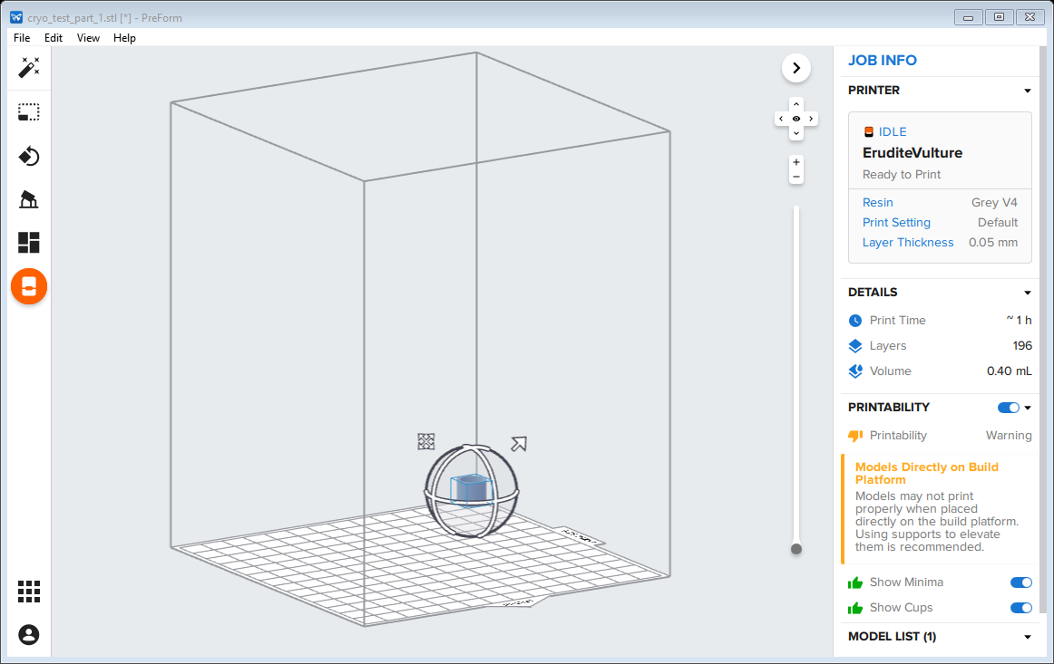

* 1. The second button can be used to choose the orientation of the part. You have the option to auto-orient along with many manual options. Auto-orient works fine in most situations.
  2. The third button allows you to add supports to the part. For this I would use the standard settings and the auto-generate button with the exception of internal supports. If you have parts with holes be sure to uncheck the internal supports box before hitting auto-generate.
  3. Once you have generated the supports hit the edit button. This will allow you to see where the supports are and verify their locations.

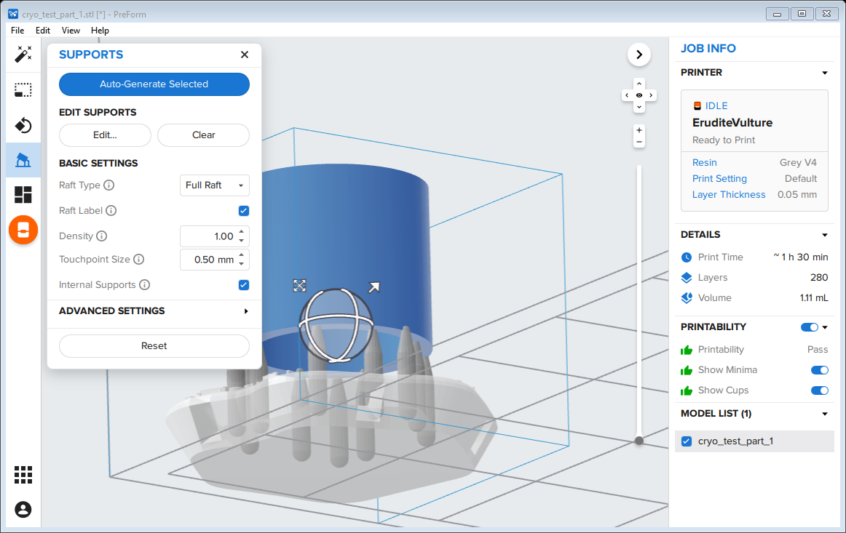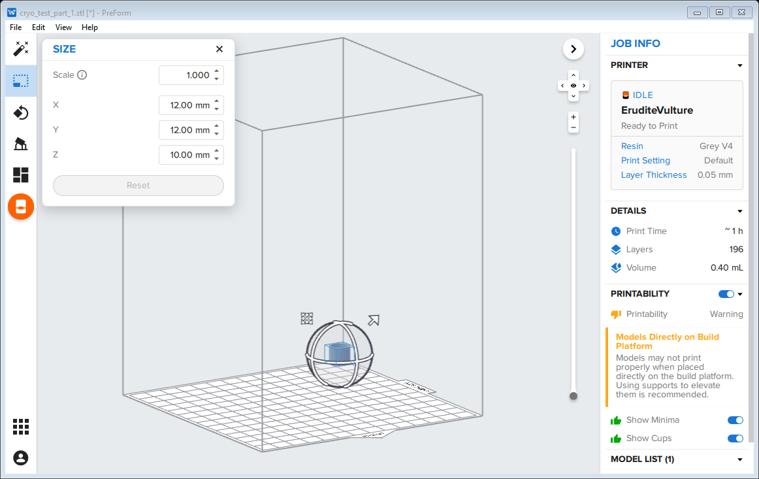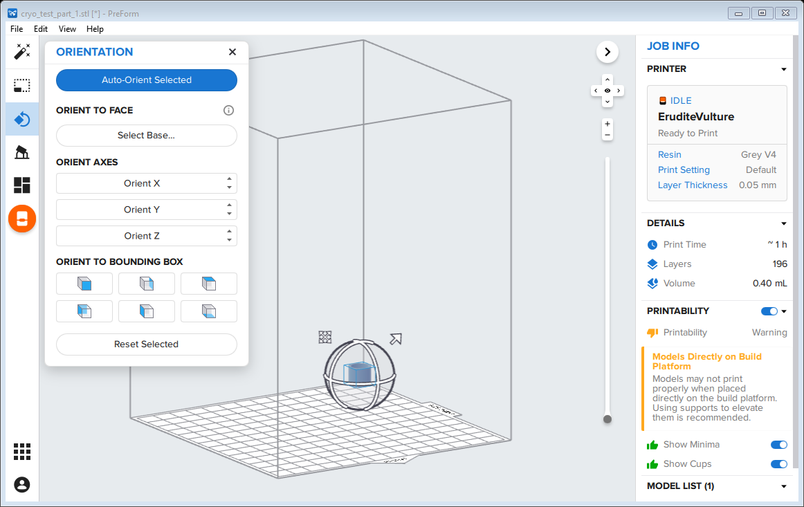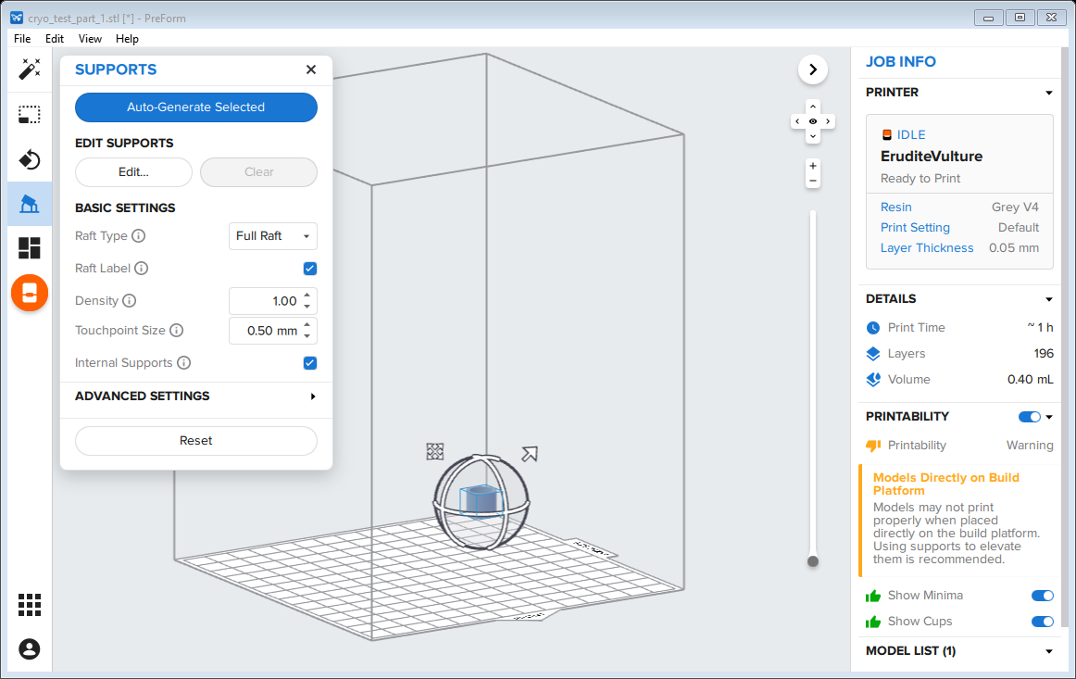

* + 1. In the edit screen you can see individual grey dots that correspond to each individual support. Looking at the part like this allows you to verify that there aren’t supports on areas of the part where you don’t want scarring or uneven surfaces.

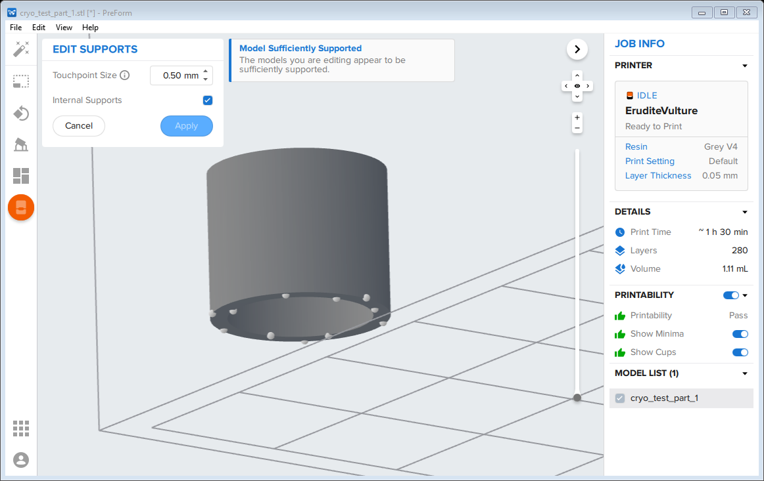

Supports

* + 1. By clicking on a dot you can remove that support. You can also add a new one by cliking somewhere on the part.
    2. In order to verify that the part has enough support and won’t fail, use the printability menu on the right. It is also helpful to note that unsupported areas of the part will turn red indicating where to add supports.

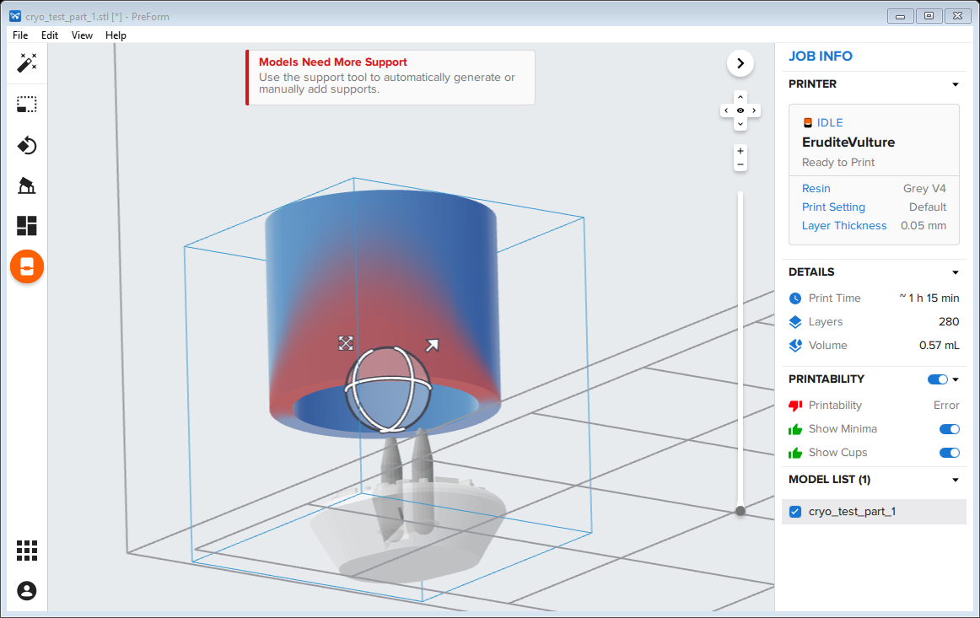

Needs more support

* 1. Once you have verified that the models are supported properly you can lay out the print using the next button on the left.

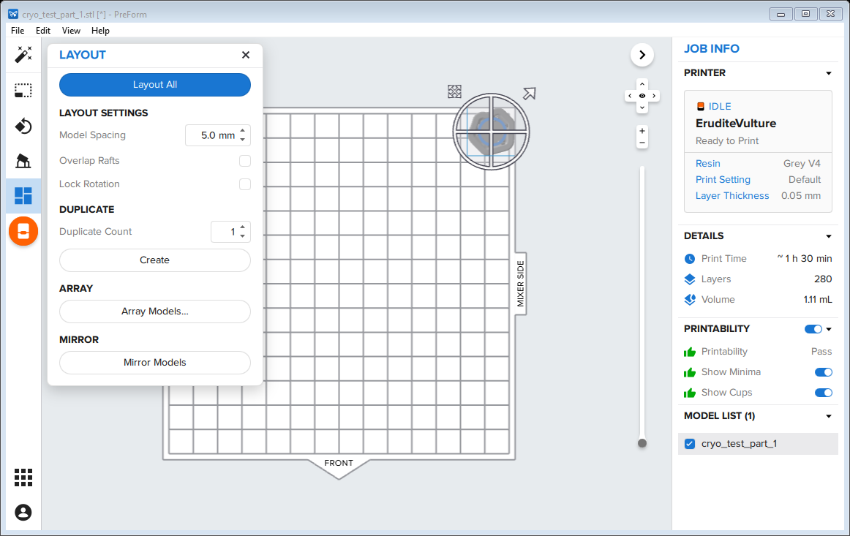

* 1. 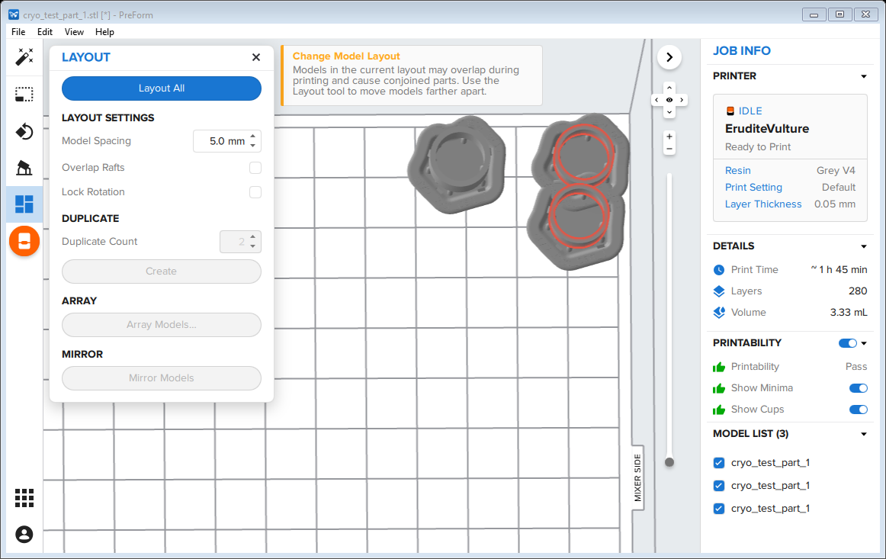The layout all feature works well. However, if you are trying to squeeze a lot of items onto the build platform you may want to arrange them manually. This is done by clicking on the part to select it and moving it. If your layout causes part overlap the parts will turn red as in the picture below.
  2. You can also use this menu to duplicate the selected parts. This is advantageous because it also duplicates the supports.

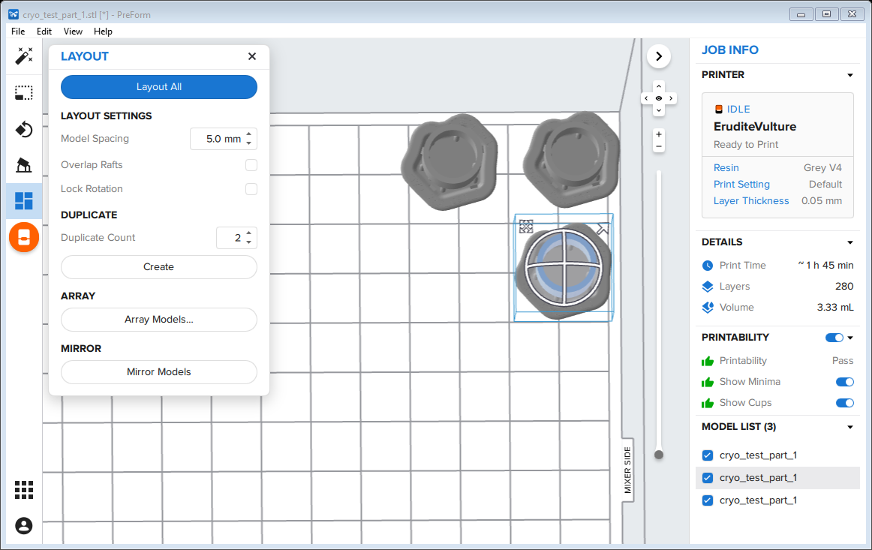

* 1. You also have the option to allow the program to do all of this automatically using the top left button. This works fairly well but it is not the best if you have parts with delicate features or surfaces you want smooth.

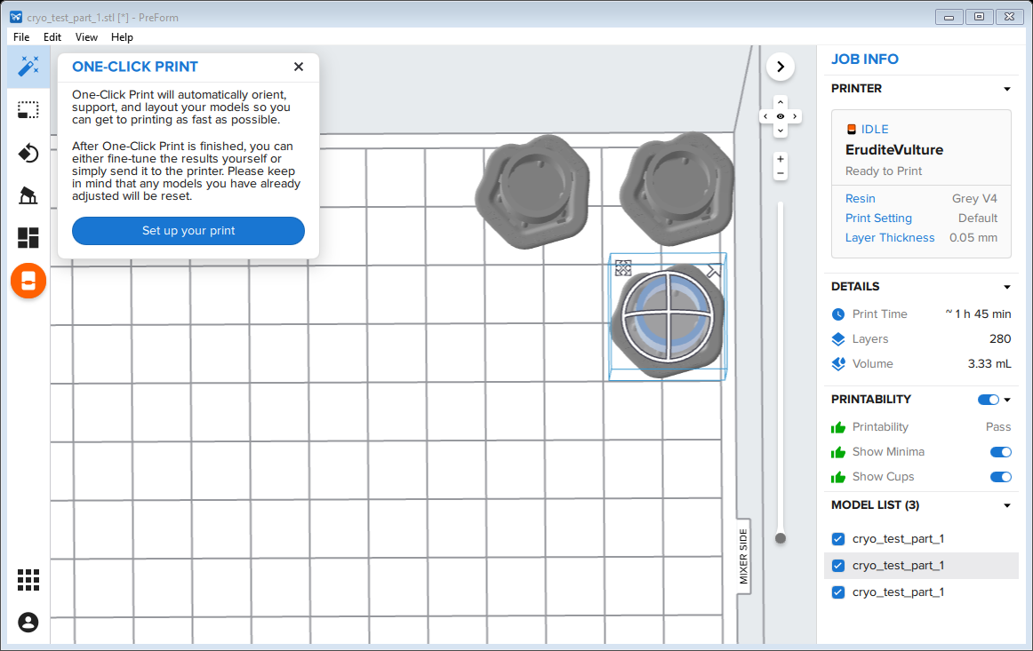

1. The next step is to send the finished file to the printer.
   1. Before sending the file to the pritner I would suggest saving it. This way if you want to print the part again in the same orientation you can. Go to file, save, and save it where you want.

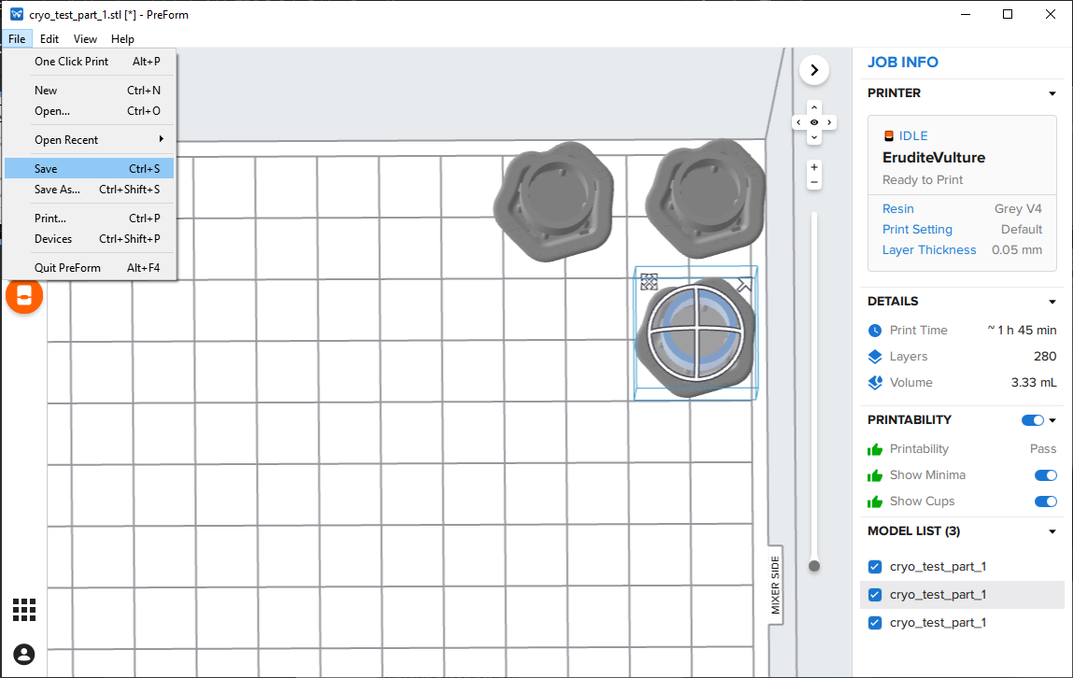

* 1. Then click on the orange pritner button.
  2. This will bring up a popup with the printer status. Use this as a last check of the printer choice, status, and resin type. Once you are satisfied, click the upload job button.

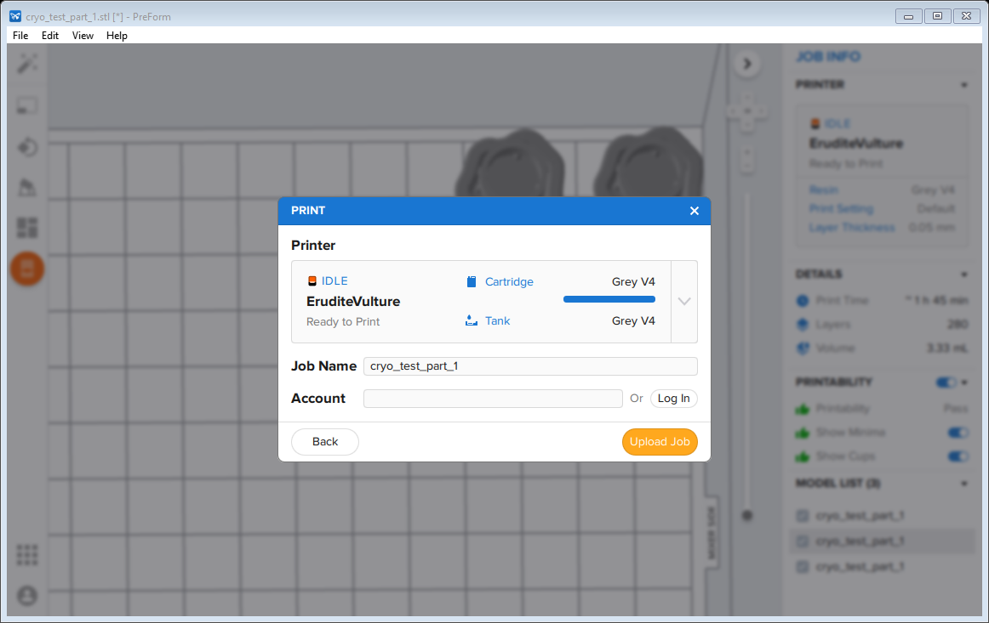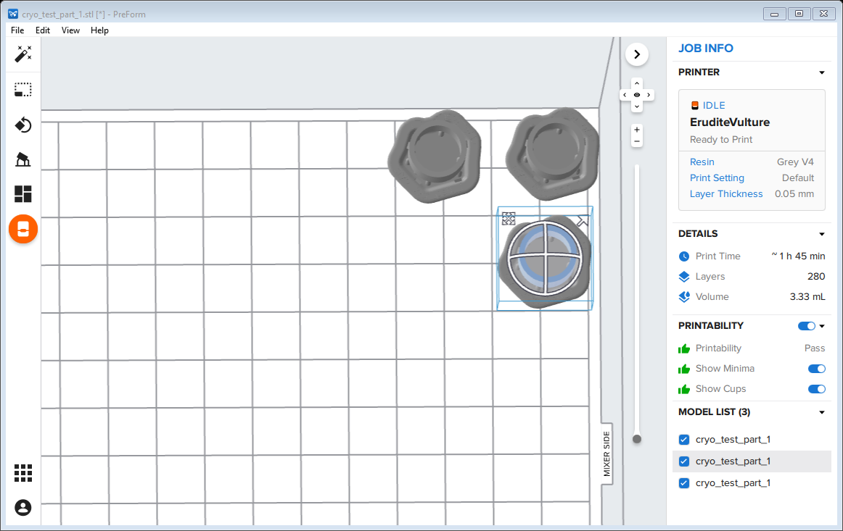

1. Once you have sent the file to the printer move to the printer to verify and start it. The printer will prompt you to open the cartridge and make sure that the build platform is locked in.
   1. The touch screen on the fron of the printer will display the file that is up next. Push print on the touchscreen and follow the prompts.

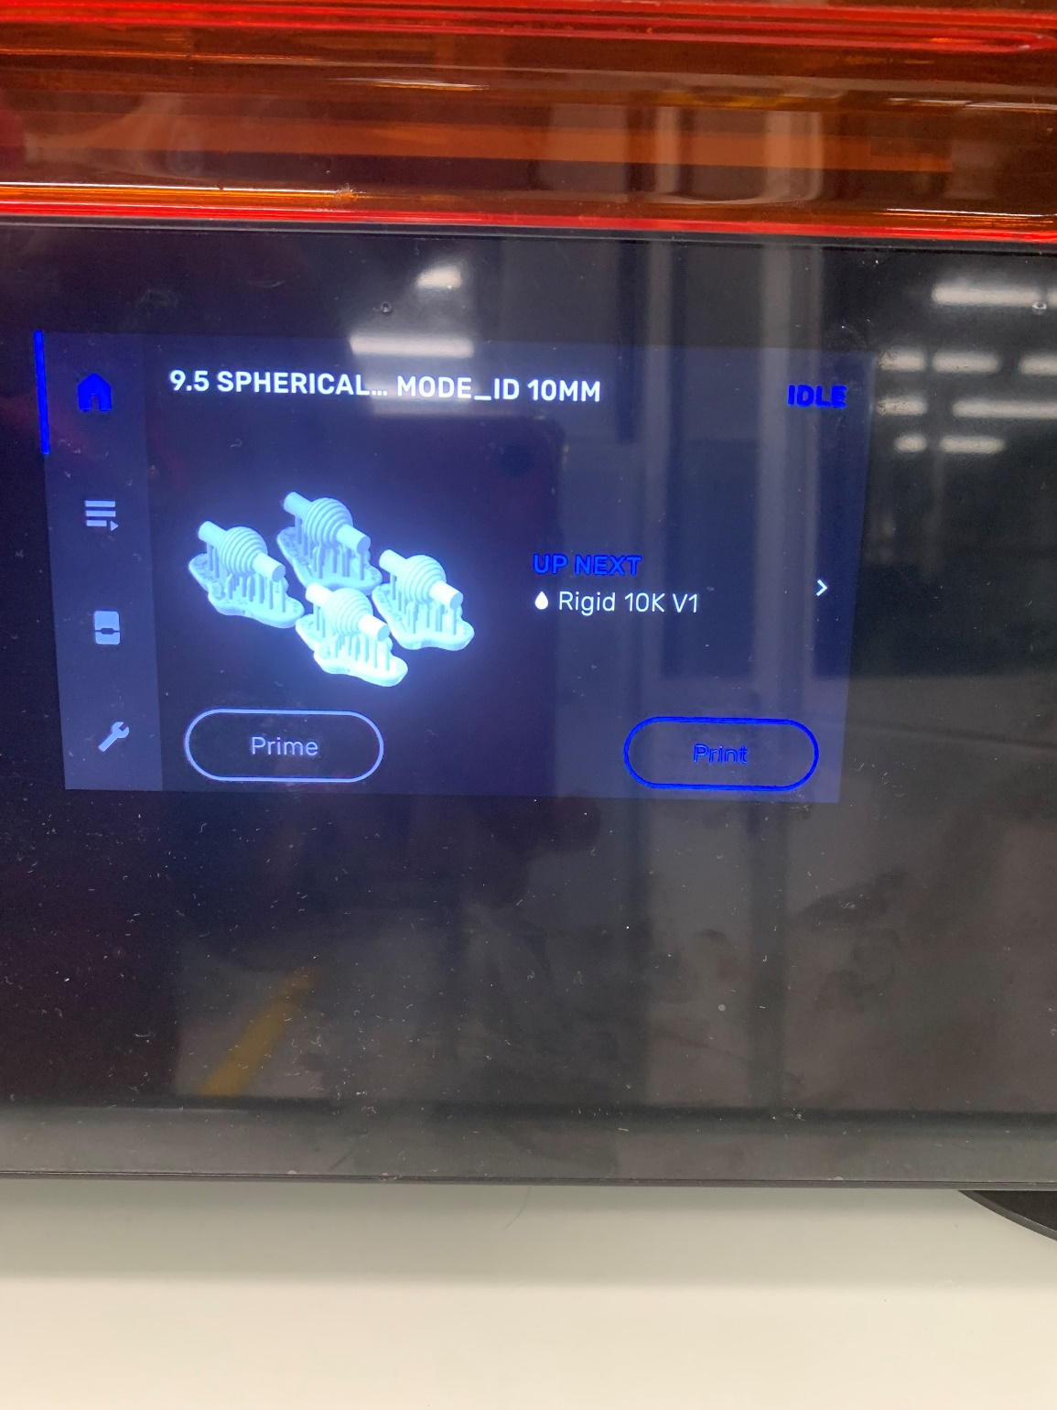

* 1. Once you have done this you will a screen saying that the printer is preparing to print.
  2. The printer will then go through a series of preprint checks. In order to ensure that the printer actually starts it is best to wait until it finishes the preprint checks as this is the most likely time for errors to occur. It can take a while so you can just leave and come back in 15-20 minutes to check on it.

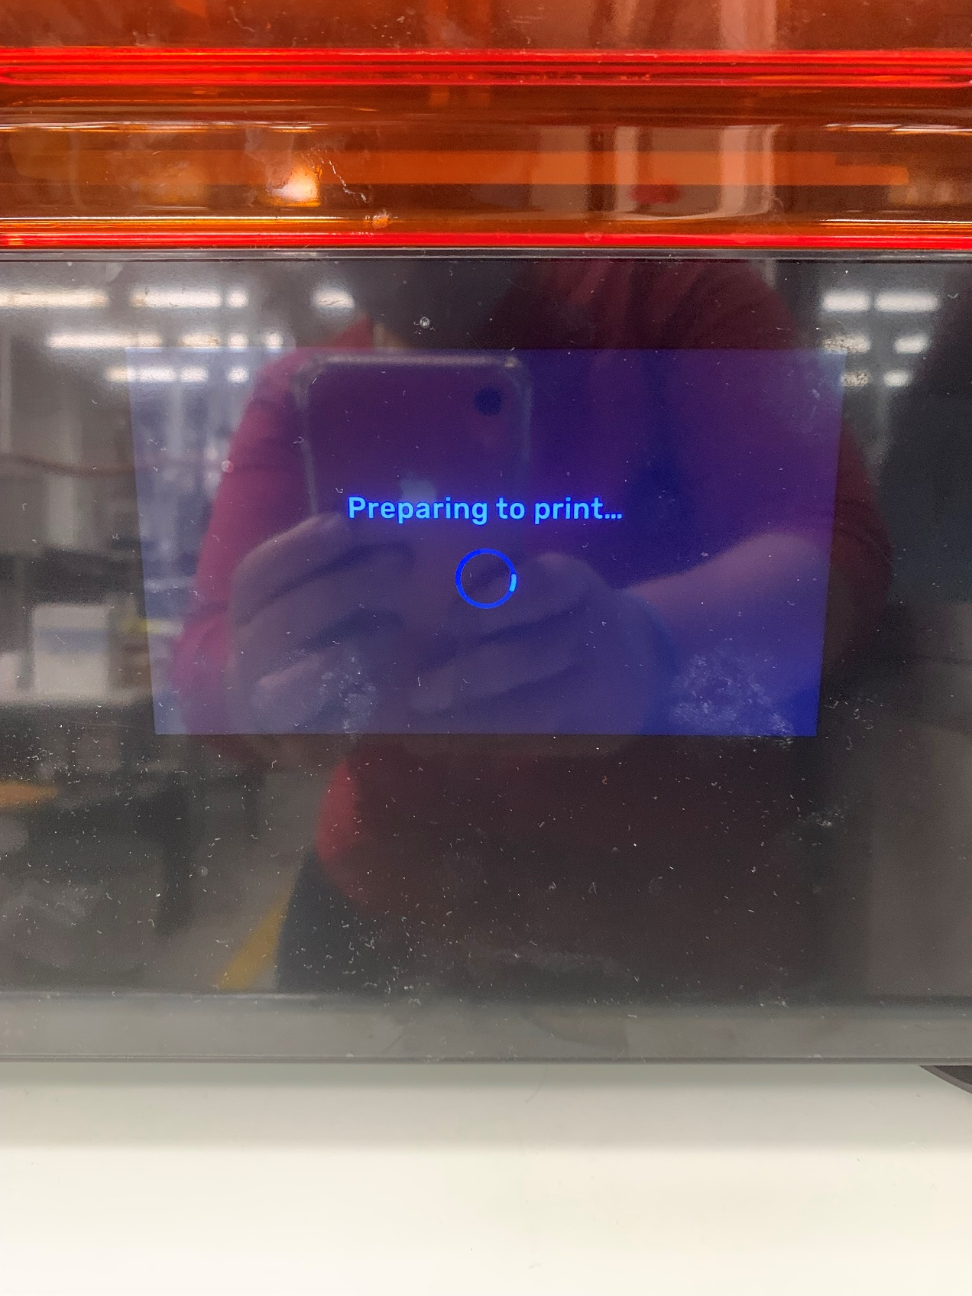

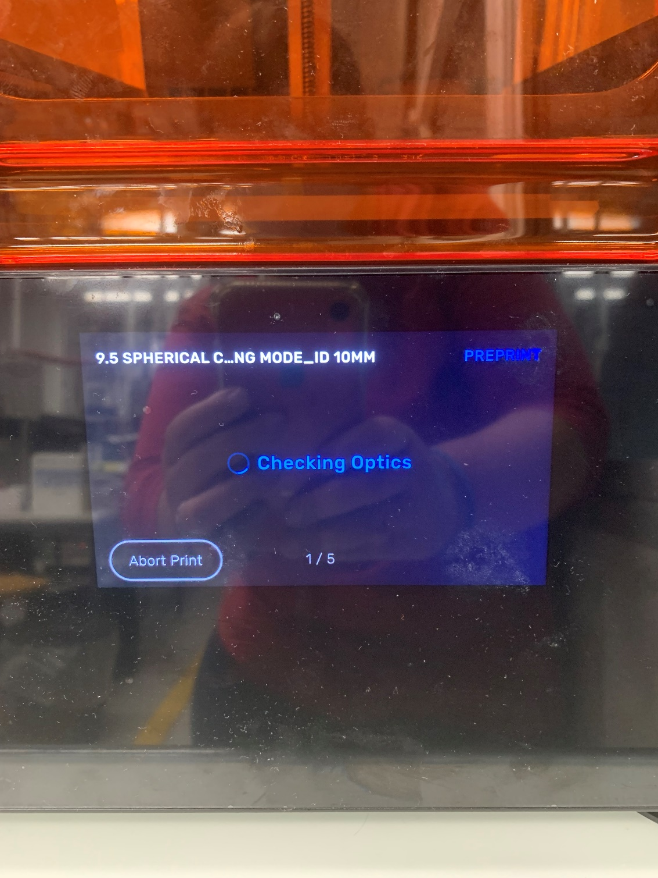

* 1. Once the printer has completed the preprint it will show that it is printing. It will also display the layer that is printing along with the remaining print time. If for some reason you need to pause or stop the print, click the pause symbol in the middle of the blue circle.

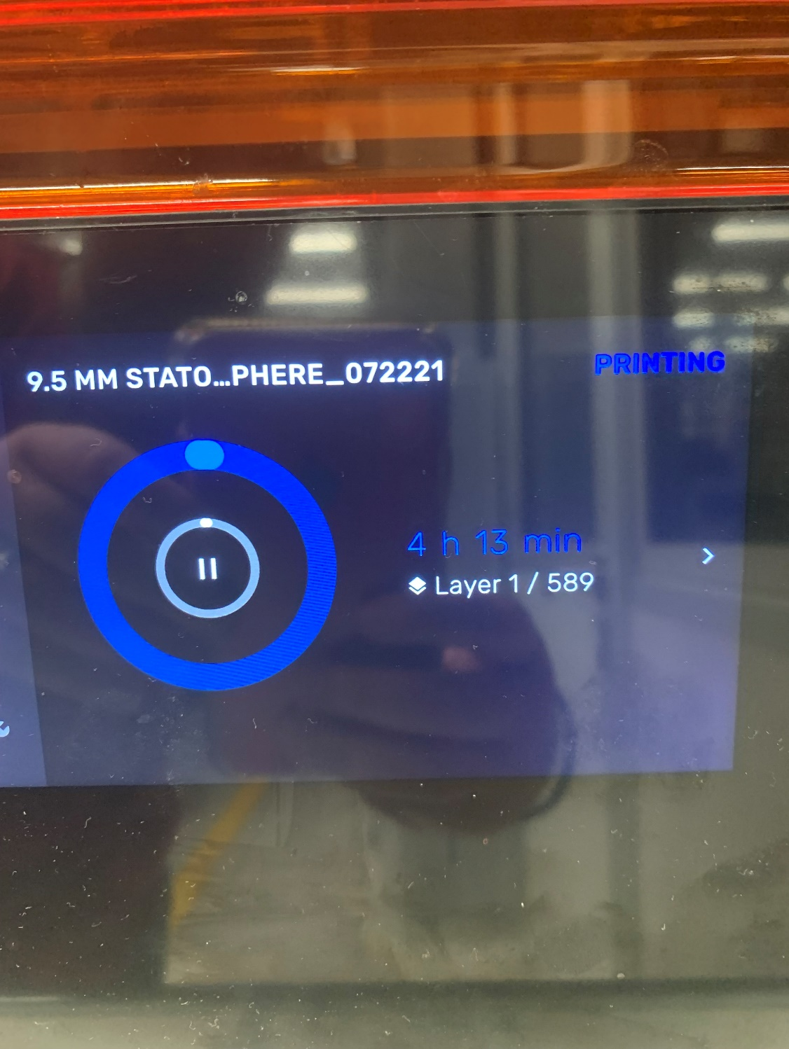

* 1. 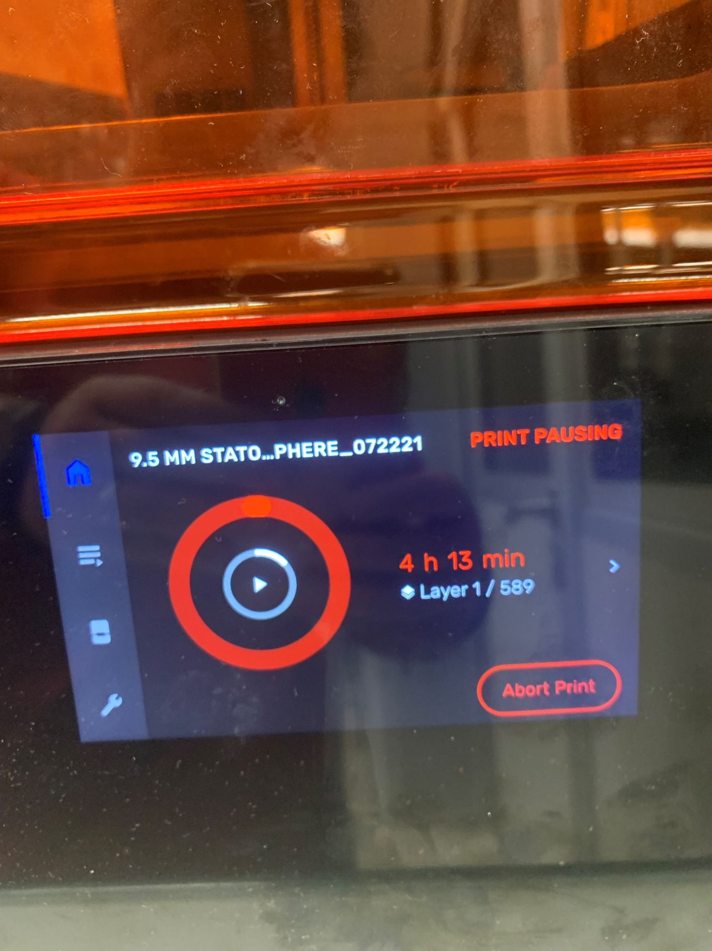Once you have done this the screen below will appear. You then have the option to press again and restart the print, to leave it paused, or to used the bottom left of the touchscreen to abort the print.
  2. Once the print is completed proceed to the removal and cleaning instructions.